Reg. No. CODE: SPH2

Ph. D COURSEWORK EXAMINATION – SEPT/OCT 2023
SUBJECT: CIVIL ENGINEERING

SPECIALIZATION PAPER 2

SURFACE AND GROUNDWATER HYDROLOGY

Time: 03 hours Maximum Marks: 50

Scholar Name: Dimple

Instructions:
- Section A Compulsory
- Section B Answer any four
- Each question carries 10 Marks

SECTION A (1 X 10 = 10)

- Explain the various climatic and physiologic factors affecting runoff and describe the methods of estimating the runoff from a catchment.

SECTION B (4 X 10 = 40)

- A catchment area of 140km² received 120cm of rainfall in a year. at the outlet of the catchment, the flow in the stream draining the catchment was found to have an average rate of:
- 1.5m³/s for the first 3 months,
- 2.0 m³/s for 6 months,
- 3.5 m³/s for the remaining 8 months.
a) What is the runoff coefficient of the catchment?
b) If the afforestation of the catchment reduces the runoff coefficient to 0.35, what is the increase
in the abstraction from precipitation due to infiltration, evaporation and transpiration for the
same annual rainfall of 120cm?

- Two parallel rivers A and B are separated by a land mass as shown in Figure 1 below. Estimate the seepage discharge from River A to River B per unit length of the rivers.
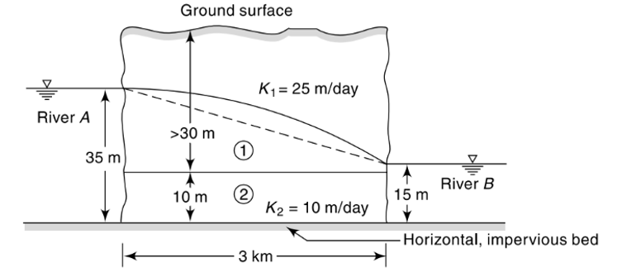
Figure 1 Showing schematic layout
- Explain Darcy’s Law of velocity of flow in porous medium.
- Derive an expression for steady state discharge of well fully penetrating a confined aquifer.
- Discuss in detail the planning of artificial recharge projects.
- Describe the recovery test to estimate the transmissivity of a confined aquifer.

********

